a
Project Design Document

Adam Fitzpatrick – C00273365
Software Development

November 22nd, 2024

Table of Contents
Introduction 3
System Architecture 4
Hardware Technology Stack 4
Waveshare 3.5" IPS Touch Screen 5
Raspberry Pi Zero 2 W 5
Anavi Infrared pHAT 6
Waveshare PN532 NFC HAT 6
Software Technology Stack 7
Raspberry Pi OS 8
Go 8
Tview 8
Libnfc 9
Ettercap 9
Infrared Lib 9
BlueZ 9
Pseudocode 10
Wi-Fi Sniffing 10
Start Sniffing 10
Stop Sniffing 10
Bluetooth Sniffing 11
Start Scanning 11
Stop Scanning 11
NFC/RFID Scanning 12
Start Scanning 12
Stop Scanning 12
NFC/RFID Emulation 13
Start Emulation 13
Stop Emulation 13
Infrared 14
Scan Infrared 14
Emit Infrared 14
Screens 16
Main Menu 16
Wi-Fi Sub-menu 16
Sniffing Sub-menu 17
Export Logs Sub-menu 17
Bluetooth Sub-menu 18
Scan for Devices Sub-menu 18
Saved Devices Sub-menu 19
NFC/RFID Sub-menu 19
Scan NFC/RFID Sub-menu 20
Emulate NFC/RFID Sub-menu 20
Infrared Sub-menu 21
Scan IR Sub-menu 21
Emulate IR Sub-menu 22
References 22

Table of Figures
Figure 1: Hardware Stack 4
Figure 2: Waveshare 3.5" IPS Touchscreen 5
Figure 3: Raspberry Pi Zero 2 W 5
Figure 4: Anavi Infrared pHAT 6
Figure 5: Waveshare PN532 NFC HAT 6
Figure 6: Software Stack 7
Figure 7: Raspberry Pi OS Lite 8
Figure 8: Go 8
Figure 9: Main Menu 16
Figure 10: Wi-Fi Sub-menu 16
Figure 11: Sniffing Sub-menu 17
Figure 12: Export Logs Sub-menu 17
Figure 13: Bluetooth Sub-menu 18
Figure 14: Scan for Devices Sub-menu 18
Figure 15: Saved Devices Sub-menu 19
Figure 16: NFC/RFID Sub-menu 19
Figure 17: Scan NFC/RFID Sub-menu 20
Figure 18: Emulate NFC/RFID Sub-menu 20
Figure 19: Infrared Sub-menu 21
Figure 20: Scan IR Sub-menu 21
Figure 21: Emulate IR Sub-menu 22

Introduction
The purpose of this design document is to outline the different features of the multi-tool. The document will outline the system’s software and hardware architecture, and the different technologies that will be utilised. It will also provide pseudocode to illustrate the flow of the different systems and provide illustrations of the various screens that the device will have.

System Architecture

Hardware Technology Stack
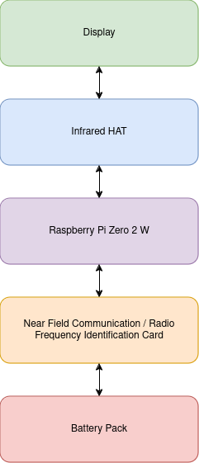Figure 1: Hardware Stack

Waveshare 3.5" IPS Touch Screen
This touch-screen IPS display from Waveshare will be used to show the system menu to the pen-tester. The screen uses a 26 pin header, as opposed to the 40 pin headers that some of the other modules use.
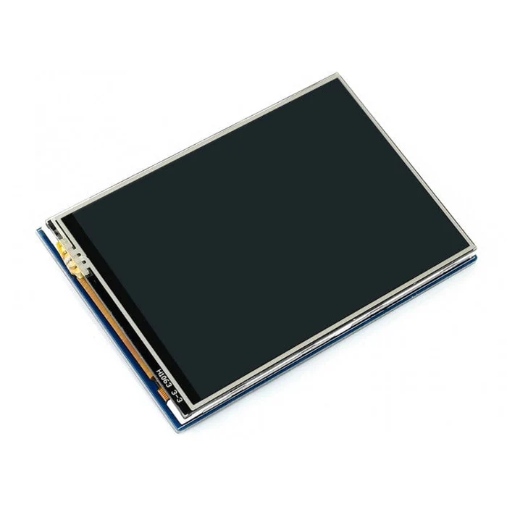Figure 2: Waveshare 3.5" IPS Touchscreen

Raspberry Pi Zero 2 W
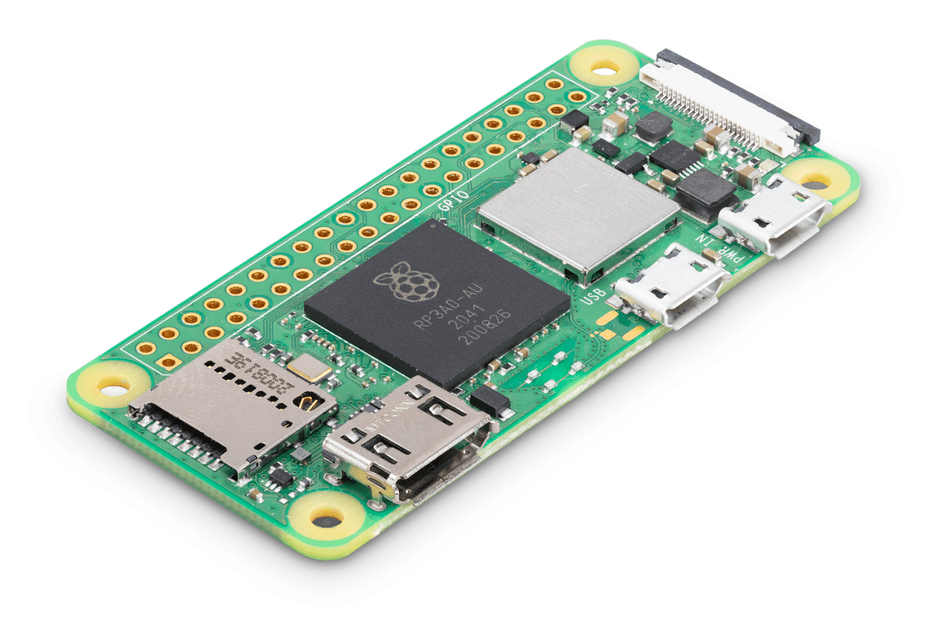Figure 3: Raspberry Pi Zero 2 W
The Raspberry Pi Zero 2 W is a micro-computer and will be the base for this project. The board hosts a quad-core 64 bit ARM central processing unit (CPU) and 512mb of random access memory (RAM). It has built in Wi-Fi and Bluetooth 4.2 which makes it ideal for this project. The board has a 40 pin general-purpose input/output (GPIO) header allowing for inter-connectivity between the different modules in the project. There are also 3 ports on the board, one for HDMI and the other 2 for micro-USB.

Anavi Infrared pHAT
The Anavi Infrared pHAT allows the Raspberry Pi to utilise infrared technologies (IR) though the use of its transmitters a receiver. This will be used to receive and emit our IR signals. The board has a 40 pin GPIO header and also contains sensor modules for temperature, humidity, barometric pressure and light.
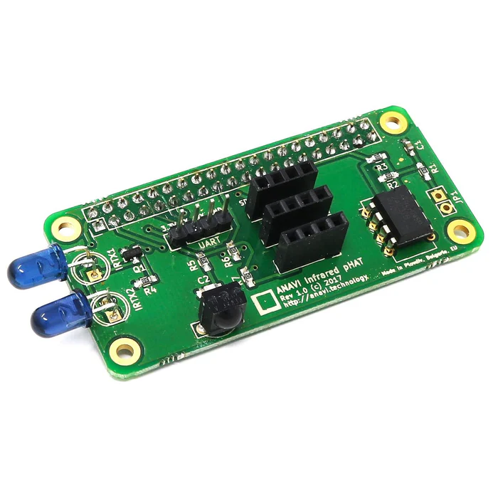Figure 4: Anavi Infrared pHAT

Waveshare PN532 NFC HAT
The Waveshare PN532 is a Raspberry Pi HAT designed to allow development boards to utilise Near Field Communications (NFC) and Radio Frequency Identification (RFID) technologies. The HAT has a 40 pin GPIO header and supports various NFC and RFID cards such as MIFARE and NTAG2. This HAT will allow the multi-tool to read and write NFC and RFID signals to and from identification tags and cards.
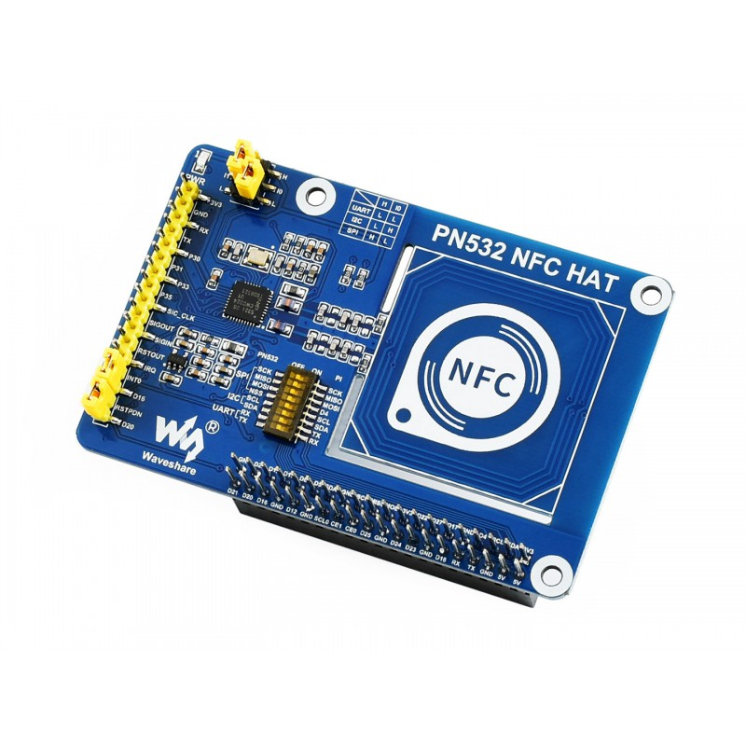Figure 5: Waveshare PN532 NFC HAT

Software Technology Stack
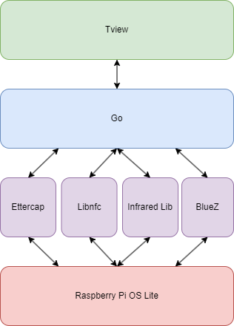Figure 6: Software Stack

Raspberry Pi OS
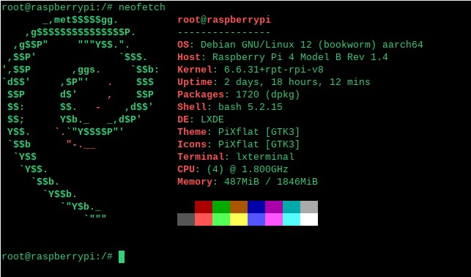Figure 7: Raspberry Pi OS Lite
Raspberry Pi OS is the officially supported operating system for the Raspberry Pi. Installing Pi OS is extremely easy, as Raspberry Pi provide an imager to flash the operating system onto an SD card so that it can be used on the board.
The operating system comes in two different installations, those being the Desktop and Lite versions. Both versions are based on Debian, however the two images vary. The Desktop version of the operating system comes as a standard desktop operating system, with some of the main features being it’s graphical user interface (GUI), web browser, media player and even an integrated development environment (IDE).
The Lite version of the operating system is much more bare bones, coming only with a command line interface. Because of this it is faster than it’s Desktop counterpart and allows for much more customizability, however the lack of a GUI and it’s reliability on the command line means that it is less intuitive to use.

Go
Go is a high-level programming language originally designed at Google. It is known for it’s simplicity, efficiency and syntactic similarity to C. This project will utilise Go for behaviour on the back-end such as for inter-compatibility between the different hardware modules.
Figure 8: Go

Tview
Tview is an open-source Terminal UI framework for Go. Tview comes with a variety of commonly used components for terminal based interfaces and allows for the customisation of these components. For this project this framework will be used to make various menus for the multi-tool system.

Libnfc
Libnfc is a library which gives applications the ability to interact with NFC devices. Specifically this project will use a wrapper by Robert Clausecker to handle the interactions between NFC identification cards and the multi-tool.

Ettercap
Ettercap is an open-source network analysis tool used for network sniffing and man-in-the-middle attacks. It has a variety of filters that can be applied when scanning networks for traffic. For this project this tool will be used for sniffing packets off of Wi-Fi networks.

Infrared Lib
This library is used for interacting with infrared devices on the Raspberry Pi. This library will be used to receive and emit infrared signals from the multi-tool.

BlueZ
BlueZ is a cross-platform package for Linux that is used to interact with Bluetooth Low Energy hardware. For this project this library will be used so that the multi-tool will be able to scan and interact with other Bluetooth enabled devices.

Pseudocode

Wi-Fi Sniffing

Start Sniffing
function runWiFiSniffer(outputLabel):
set isSniffing to true
show outputLabel
logFileName = "sniff_log_" + current Unix timestamp + ".pcap"
command = scan()
errorBuffer = createBuffer()
if command fails to start:
log "Error starting command: " + error message
updateLabel(outputLabel, "Error starting sniffing: " + error message)
return
updateLabel(outputLabel, "Sniffing in progress...")
if command fails while running:
log "Command finished with error: " + error message
updateLabel(outputLabel, "Command finished with error: " + error message + "\n" + errorBuffer contents)

Stop Sniffing
function stopWiFiSniffer(outputLabel)
If sniffing is ongoing:
if command exists and process exists
kill process
if error occurs:
log “Error stopping command:” + error
updateLabel(outputLabel, “Error stopping sniffing”)
return
updateLabel(outputLabel, “Sniffing stopped. Log saved as “ + logFileName)
else:
updateLabel(outputLabel, “No sniffing process to stop”)

set isSniffing to false

Bluetooth Sniffing

Start Scanning
function startBluetoothScanner(outputLabel):
set isScanning to true
show outputLabel
command = initializeBluetoothScan()
errorBuffer = createBuffer()
if command fails to start:
log "Error starting command: " + error message
updateLabel(outputLabel, "Error starting scanning: " + error message)
return
updateLabel(outputLabel, "Scanning in progress...")
for each scannedDevice in scanResults:
append "Device: " + scannedDevice to outputLabel
if command fails while running:
log "Command finished with error: " + error message
updateLabel(outputLabel, "Command finished with error: " + error message + "\n" + errorBuffer contents)

Stop Scanning
function stopBluetoothScanner(outputLabel)
If scanning is ongoing:
if command exists and process exists:
kill process
if error occurs:
log “Error stopping command:” + error
updateLabel(outputLabel, “Error stopping scan”)
return
updateLabel(outputLabel, “Scanning stopped. Log saved as “ + logFileName)
else:
updateLabel(outputLabel, “No sniffing process to stop”)

set isSscanning to false

NFC/RFID Scanning

Start Scanning
function startNFCScanner(outputLabel):
set isScanning to true

show outputLabel

thisNFC = "NFC_" + current Unix timestamp

command = initializeNFCScan()

errorBuffer = createBuffer()

if command fails to start:
log "Error starting command: " + error message
updateLabel(outputLabel, "Error starting scan: " + error message)
return

updateLabel(outputLabel, "Scanning in progress... Please hold your card to the reader.")
initiateScanning(command)

while isScanning:
scannedData = readNFCData() // Function to read NFC data from the scanner
if scannedData is not empty:
append "Scanned NFC Data: " + scannedData to outputLabel

if command fails while running:
log "Command finished with error: " + error message
updateLabel(outputLabel, "Command finished with error: " + error message + "\n" + errorBuffer contents)

set isScanning to false

Stop Scanning
function stopNFCScanner(outputLabel):
if isScanning is true:
if command exists and process exists:
try to kill the process
if termination fails:
log "Error stopping command: " + error message
updateLabel(outputLabel, "Error stopping scanning.")
return

updateLabel(outputLabel, "Scanning stopped successfully.")

else:
updateLabel(outputLabel, "No scanning process to stop.")

set isScanning to false

NFC/RFID Emulation

Start Emulation
function emulateNFC(outputLabel):
set isEmulating to true
thisIdentifier = generateNFCID()

errorBuffer = createBuffer()

if thisIdentifier fails to initialize:
log "Error initializing NFC identifier: " + error message
updateLabel(outputLabel, "Error initializing NFC emulation: " + error message)
return

updateLabel(outputLabel, "NFC Emulation in progress...")
broadcastSignal(thisIdentifier)

if broadcasting thisIdentifier fails:
log "Error during NFC emulation: " + error message
append "Error: " + errorBuffer contents to outputLabel
return

updateLabel(outputLabel, "NFC Emulating Identifier: " + thisIdentifier)

if emulation process ends with error:
log "NFC emulation ended with error: " + error message
updateLabel(outputLabel, "NFC emulation ended with error: " + error message + "\n" + errorBuffer contents)

Stop Emulation
function stopEmulation(outputLabel):
if emulation process exists and is running:
try to terminate the emulation
if termination fails:
log "Error stopping NFC emulation: " + error message
updateLabel(outputLabel, "Error stopping NFC emulation: " + error message)
return

updateLabel(outputLabel, "NFC Emulation stopped successfully.")
else:
updateLabel(outputLabel, "No active NFC emulation to stop.")

set isEmulating to false

Infrared

Scan Infrared
function scanInfrared(outputLabel):
set isScanning to true
show outputLabel
infraredScanner = initializeInfraredScanner()
errorBuffer = createBuffer()
if infraredScanner fails to initialize:
log "Error starting infrared scanning: " + error message
updateLabel(outputLabel, "Error starting infrared scanning: " + error message)
return
updateLabel(outputLabel, "Infrared scanning in progress...")
scanInfrared(infraredScanner)
for each detectedSignal in scanResults:
append "Detected Signal: " + detectedSignal to outputLabel
if scanning process fails:
log "Error during infrared scanning: " + error message
append "Error: " + errorBuffer contents to outputLabel
return
updateLabel(outputLabel, "Infrared scanning completed.")
set isScanning to false

Emit Infrared
function manageInfraredEmission(outputLabel, action):
if action == "start":
set isEmitting to true

show outputLabel

infraredEmitter = initializeInfraredEmitter()

errorBuffer = createBuffer()

if infraredEmitter fails to initialize:
log "Error starting infrared emission: " + error message
updateLabel(outputLabel, "Error starting infrared emission: " + error message)
return

updateLabel(outputLabel, "Infrared emission in progress...")
emitSignal(infraredEmitter)

if emission process fails:
log "Error during infrared emission: " + error message
append "Error: " + errorBuffer contents to outputLabel
return

updateLabel(outputLabel, "Infrared emission started successfully.")

else if action == "stop":
if infraredEmitter exists and is active:
try to terminate the infrared emission
if termination fails:
log "Error stopping infrared emission: " + error message
updateLabel(outputLabel, "Error stopping infrared emission: " + error message)
return

updateLabel(outputLabel, "Infrared emission stopped successfully.")
else:
updateLabel(outputLabel, "No active infrared emission to stop.")
set isEmitting to false

Screens

Main Menu
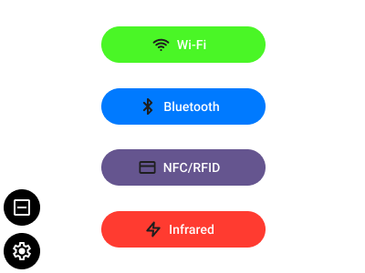Figure 9: Main Menu

Wi-Fi Sub-menu
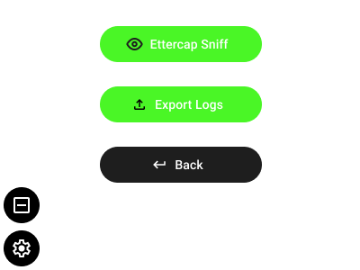Figure 10: Wi-Fi Sub-menu

Sniffing Sub-menu
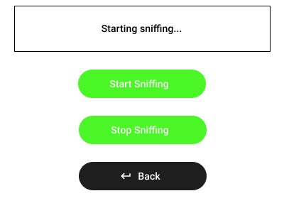Figure 11: Sniffing Sub-menu

Export Logs Sub-menu
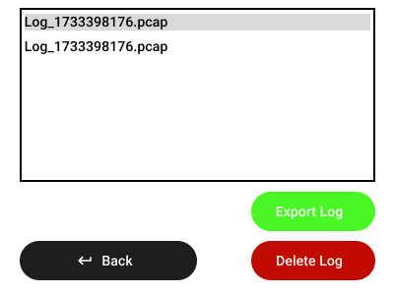Figure 12: Export Logs Sub-menu

Bluetooth Sub-menu
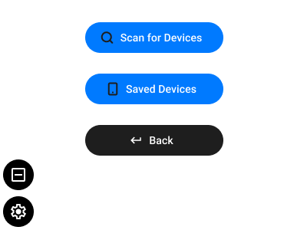Figure 13: Bluetooth Sub-menu

Scan for Devices Sub-menu
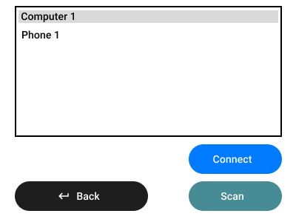Figure 14: Scan for Devices Sub-menu

Saved Devices Sub-menu
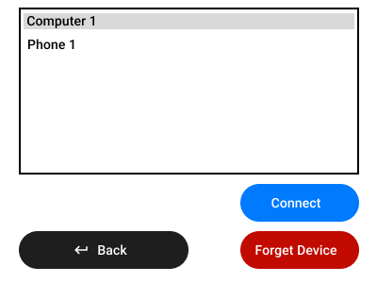Figure 15: Saved Devices Sub-menu

NFC/RFID Sub-menu
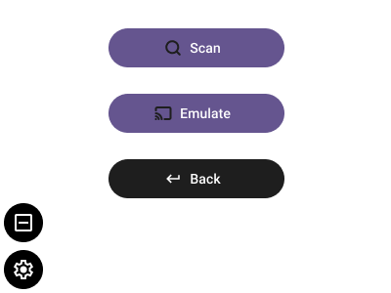Figure 16: NFC/RFID Sub-menu

Scan NFC/RFID Sub-menu
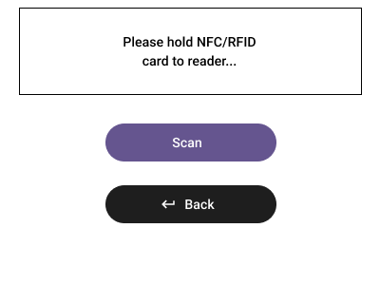Figure 17: Scan NFC/RFID Sub-menu

Emulate NFC/RFID Sub-menu
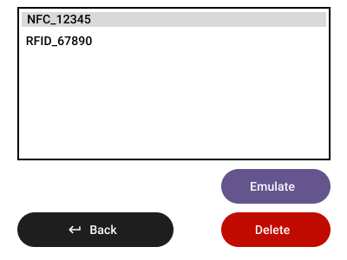Figure 18: Emulate NFC/RFID Sub-menu

Infrared Sub-menu
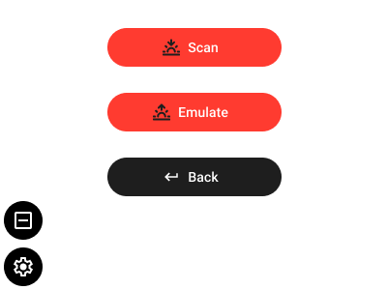Figure 19: Infrared Sub-menu

Scan IR Sub-menu
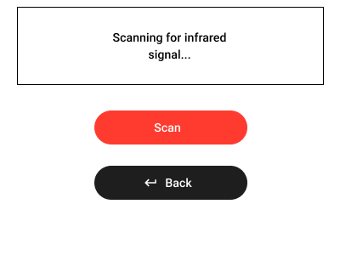Figure 20: Scan IR Sub-menu

Emulate IR Sub-menu
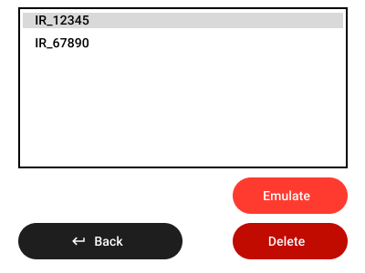Figure 21: Emulate IR Sub-menu

References
[1] The Pi Hut. Available at: https://thepihut.com/ (Accessed: 05 December 2024).
[2] Raspberry Pi. Available at: https://www.raspberrypi.com/products/raspberry-pi-zero-2-w/ (Accessed: 05 December 2024).
[3] Raspberry pi OS lite vs. desktop: What’s the difference? (2024) RaspberryTips. Available at: https://raspberrytips.com/raspberry-pi-os-lite-vs-desktop/ (Accessed: 05 December 2024).
[4] Go. Available at: https://go.dev/ (Accessed: 05 December 2024).
[5] Tview. Available at: https://github.com/rivo/tview (Accessed: 05 December 2024).
[6] NFC Go Package. Available at: https://pkg.go.dev/github.com/fuzxxl/nfc (Accessed: 05 December 2024).
[7] Ettercap Home Page. Available at: https://www.ettercap-project.org/ (Accessed: 05 December 2024).
[8] Smarthome-go/infrared: A go library used for receiving signals from infrared remote controls, GitHub. Available at: https://github.com/smarthome-go/infrared (Accessed: 05 December 2024).
[9] Tinygo-org/bluetooth: Cross-platform Bluetooth API for GO and tinygo. supports linux, macos, Windows, and bare metal using Nordic softdevice or HCI, GitHub. Available at: https://github.com/tinygo-org/bluetooth (Accessed: 05 December 2024).

